Program to print Hello World in a Message Box on clicking on a button

Private Sub Command1_Click()
MsgBox ("Hello World")
End Sub

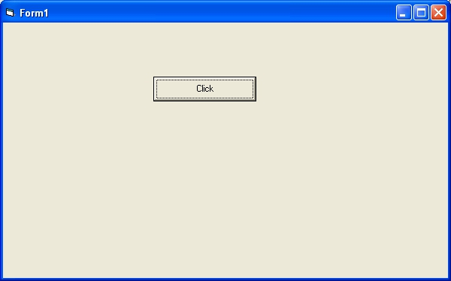
Program to add,subtract,multiply and divide two numbers

Private Sub Command1_Click()
Dim a As Integer
Dim b As Integer
Dim sum As Integer
a = CInt(Text1.Text)
b = CInt(Text2.Text)
sum = a + b
Label3.Caption = "Sum of Two Numbers is " & sum
End Sub

Private Sub Command2_Click()
Dim a As Integer
Dim b As Integer
Dim diff As Integer
a = CInt(Text1.Text)
b = CInt(Text2.Text)
diff = a - b
Label3.Caption = "Difference of Two Numbers is " & diff
End Sub

Private Sub Command3_Click()
Dim a As Integer
Dim b As Integer
Dim diff As Integer
a = CInt(Text1.Text)
b = CInt(Text2.Text)
product = a * b
Label3.Caption = "Product of Two Numbers is " & product
End Sub

Private Sub Command4_Click()
Dim a As Integer
Dim b As Integer
Dim quotient As Integer
a = CInt(Text1.Text)
b = CInt(Text2.Text)
quotient = a / b
Label3.Caption = "Quotient of Two Numbers is " & quotient
End Sub

Private Sub Command5_Click()
Dim a As Integer
Dim b As Integer
Dim remainder As Integer
a = CInt(Text1.Text)
b = CInt(Text2.Text)
remainder = a Mod b
Label3.Caption = "Remainder of Two Numbers is " & remainder
End Sub

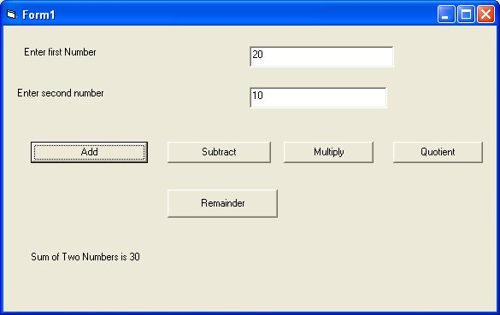

Program to find area and perimeter of square

Private Sub Command1_Click()
Dim side As Integer
Dim area As Integer
Dim perimeter As Integer
side = CInt(Text1.Text)
area = side * side
Label2.Caption = "Area of square is " & area
End Sub

Private Sub Command2_Click()
Dim side As Integer
Dim area As Integer
Dim perimeter As Integer
side = CInt(Text1.Text)
perimeter = 4 * side
Label2.Caption = "Perimeter of square is " & perimeter
End Sub

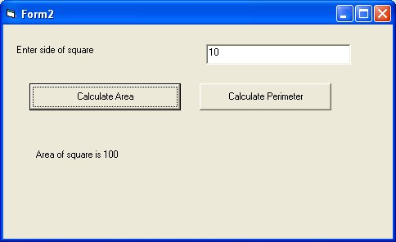

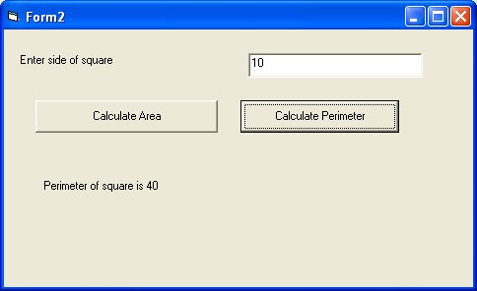
Program to find area and perimeter of rectangle
length and breadth are entered by user in textboxes

Private Sub Command1_Click()
Dim length As Integer
Dim breadth As Integer
Dim area As Integer
length = CInt(Text1.Text)
breadth = CInt(Text2.Text)
area = length * breadth
Label3.Caption = "Area of Rectangle is " & area
End Sub

Private Sub Command2_Click()
Dim length As Integer
Dim breadth As Integer
Dim perimeter As Integer
length = CInt(Text1.Text)
breadth = CInt(Text2.Text)
perimeter = 2 * (length + breadth)
Label3.Caption = "Perimeter of Rectangle is " & perimeter
End Sub

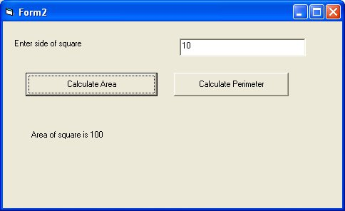
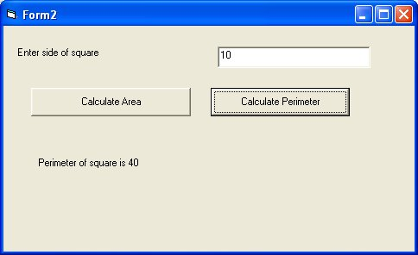

program to find volume of box
width, depth and height are entered by user in textboxes

Private Sub Command1_Click()
Dim width As Integer
Dim depth As Integer
Dim height As Integer
Dim volume As Integer
width = CInt(Text1.Text)
depth = CInt(Text2.Text)
height = CInt(Text3.Text)
volume = width * depth * height
Label4.Caption = "Volume of Box is " & volume
End Sub
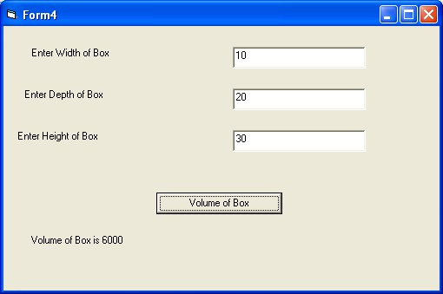

program to find area and circumference of circle
radius is entered by user in textbox

Private Sub Command1_Click()
Dim radius As Double
Dim area As Double
radius = CDbl(Text1.Text)
area = 3.14 * radius * radius
Label2.Caption = "Area of Circle is " & area
End Sub

Private Sub Command2_Click()
Dim radius As Double
Dim circumference As Double
radius = CDbl(Text1.Text)
circumference = 2 * 3.14 * radius
Label2.Caption = "Circumference of Circle is " & circumference
End Sub

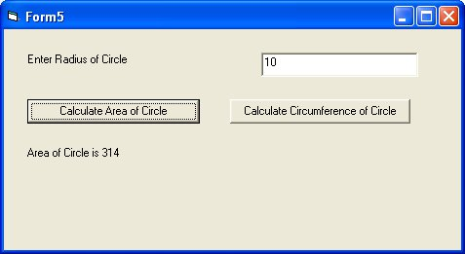
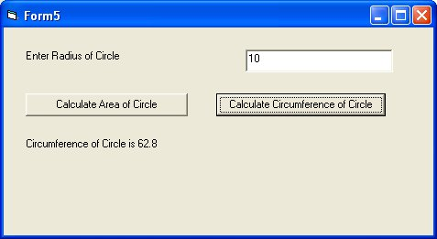
program to find simple interest based on principal amount , rate and time

Private Sub Command1_Click()
Dim principal As Double
Dim rate As Double
Dim time As Double
Dim si As Double
principal = CDbl(Text1.Text)
rate = CDbl(Text2.Text)
time = CDbl(Text3.Text)
si = principal * rate * time
Label4.Caption = "Simple Interest is " & si
End Sub

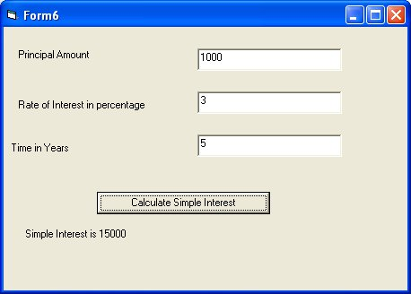
program to find 10% discount based on price entered by user in textbox

Private Sub Command1_Click()
Dim price As Double
Dim discount As Double
price = CDbl(Text1.Text)
discount = price * 0.1
Label2.Caption = "Discount is " & discount
End Sub

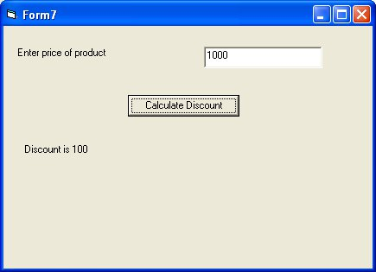

program to declare a constant pi with value as 3.14

Private Sub Command1_Click()
Const pi As Double = 3.14
Dim radius As Double
Dim area As Double
radius = CDbl(Text1.Text)
area = pi * radius * radius
Label3.Caption = "Area of Circle is " & area
End Sub

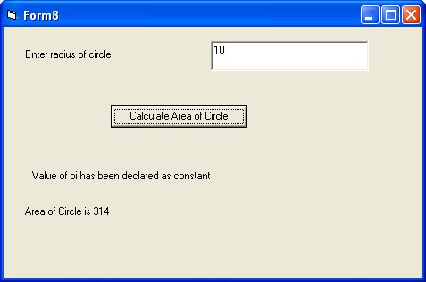

program to demonstrate if statement

Private Sub Command1_Click()
Dim a As Integer
a = CInt(Text1.Text)
If a = 10 Then
MsgBox ("Value of a is 10")
Else
MsgBox ("Value of a is not equal to 10")
End If
End Sub

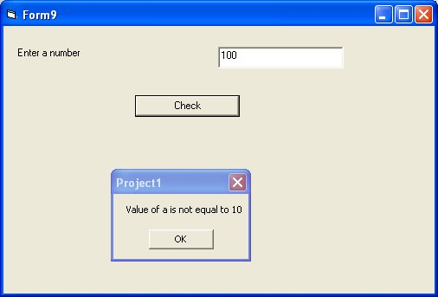
program to check whether number is greater than 10 or not

Private Sub Command1_Click()
Dim a As Integer
a = CInt(Text1.Text)
If a > 10 Then
MsgBox ("Value of number is greater than 10")
Else
MsgBox ("Value of a is less than or equal to 10")
End If
End Sub

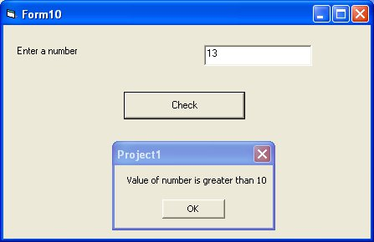

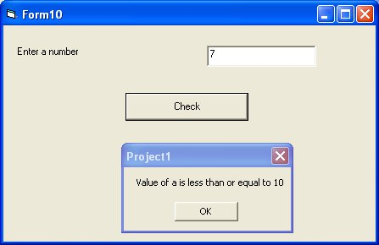
program to check whether a is greater than 10 or less than 10

Private Sub Command1_Click()
Dim a As Integer
a = CInt(Text1.Text)
If a < 10 Then
MsgBox ("Value of number is less than 10")
Else
MsgBox ("Value of a is greater than or equal to 10")
End If
End Sub

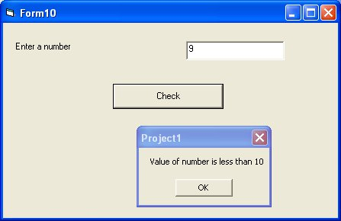
program to input temperature from user and check whether it is boiling point of water is not

Private Sub Command1_Click()
Dim a As Integer
a = CInt(Text1.Text)
If a < 10 Then
MsgBox ("Value of number is less than 10")
Else
MsgBox ("Value of a is greater than or equal to 10")
End If
End Sub

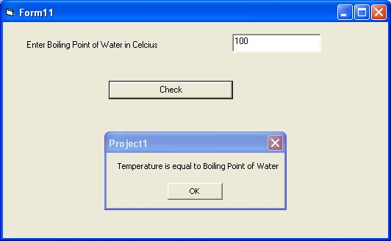
program to calculate check eligibility of person to vote based on age

Private Sub Command1_Click()
Dim age As Integer
age = CInt(Text1.Text)
If age >= 18 Then
MsgBox ("Person is eligible to vote")
Else
MsgBox ("Person is not eligible to vote")
End If
End Sub

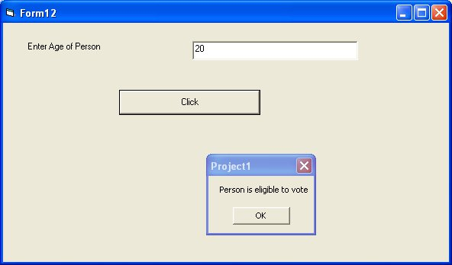

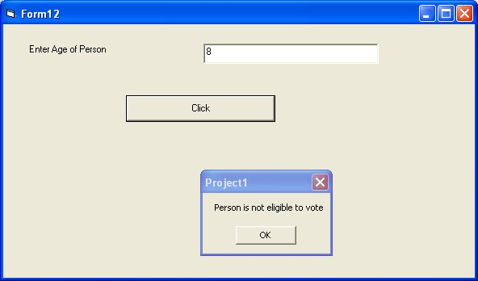
program to check whether number is even or odd

Private Sub Command1_Click()
Dim a As Integer
a = CInt(Text1.Text)
If a Mod 2 = 0 Then
MsgBox ("Number is Even")
Else
MsgBox ("Number is Odd")
End If
End Sub

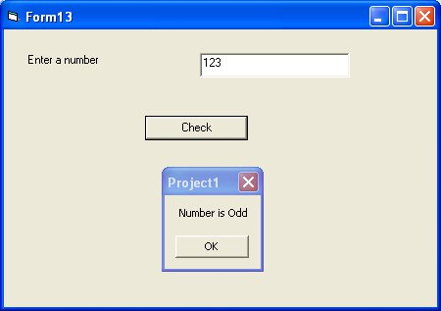
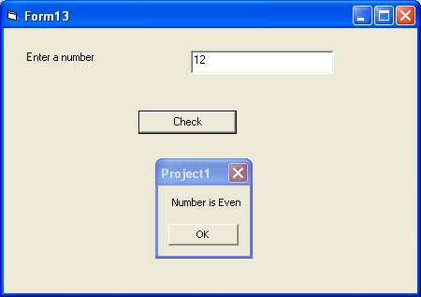

program to check an alphabet is vowel or not

Private Sub Command1_Click()
Dim a As String
a = Text1.Text
If a = "a" Or a = "e" Or a = "i" Or a = "o" Or a = "u" Then
MsgBox ("Alphabet is vowel")
Else
MsgBox ("Alphabet is not vowel")
End If
End Sub

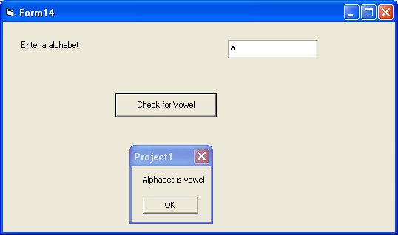
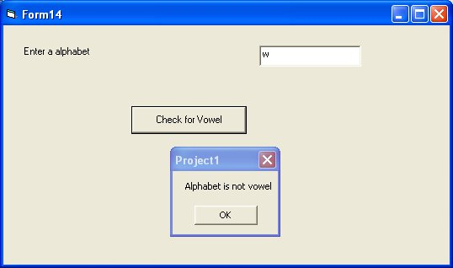
program to enter marks from user and check whether marks are between 80 and 90 using and operator

Private Sub Command1_Click()
Dim marks As Integer
marks = CInt(Text1.Text)
If marks >= 80 And marks <= 100 Then
MsgBox ("Marks are between 80 and 90")
Else
MsgBox ("Marks are not between 80 and 90")
End If
End Sub

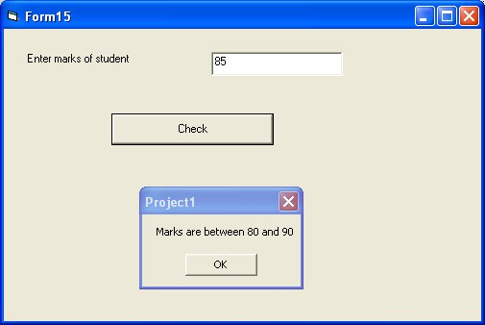

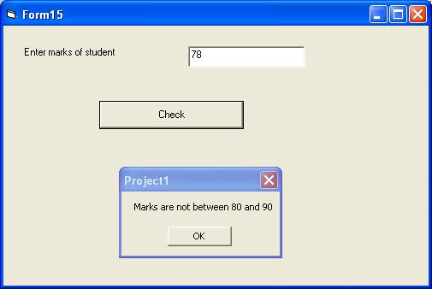

program to calculate grade of student based on marks

Marks | grade
80 to 100 | A
70 to 79 | B
60 to 69 | C
Less than 60 | D

Private Sub Command1_Click()
Dim marks As Integer
Dim grade As String
marks = CInt(Text1.Text)
If marks >= 80 And marks <= 100 Then
grade = "A"
ElseIf marks >= 70 And marks < 80 Then
grade = "B"
ElseIf marks >= 60 And marks < 70 Then
grade = "C"
Else
grade = "D"
End If
MsgBox ("Grade of student is " & grade)
End Sub

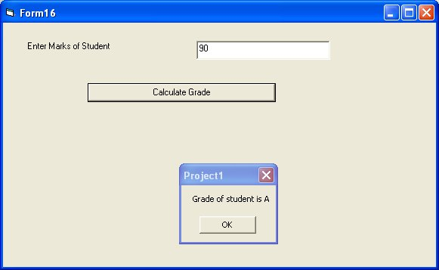
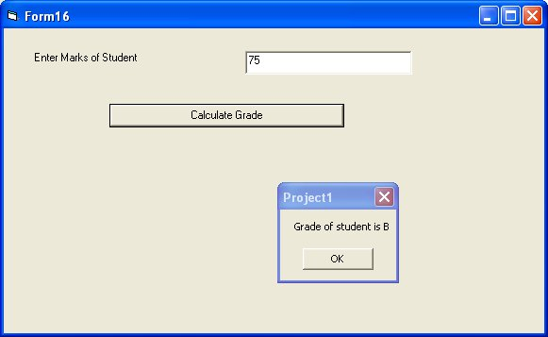
program to demonstrate select case statement
programs asks user for day in number and displays day in words in a messagebox

Private Sub Command1_Click()
Dim a As Integer
a = CInt(Text1.Text)
Select Case a
Case 1
MsgBox "Day is Monday"
Case 2
MsgBox "Day is Tuesday"
Case 3
MsgBox "Day is Wednesday"
Case 4
MsgBox "Day is Thursday"
Case 5
MsgBox "Day is Friday"
Case 6
MsgBox "Day is Saturday"
Case 7
MsgBox "Day is Sunday"
Case Else
MsgBox "Enter a day between 1 and 7"
End Select
End Sub

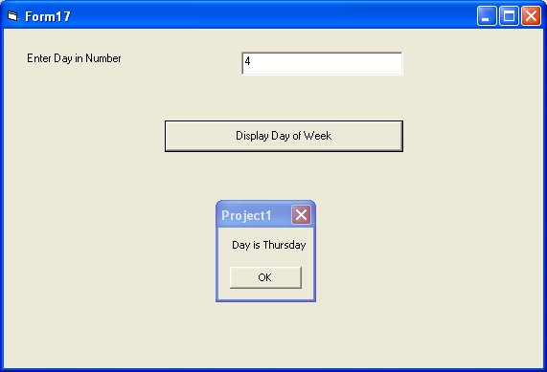

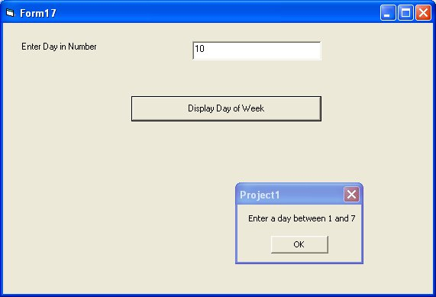
program to demonstrate for loop to print numbers from 1 to 10 in a ListBox

Private Sub Command1_Click()
Dim i As Integer
For i = 1 To 10
List1.AddItem (i)
Next
End Sub

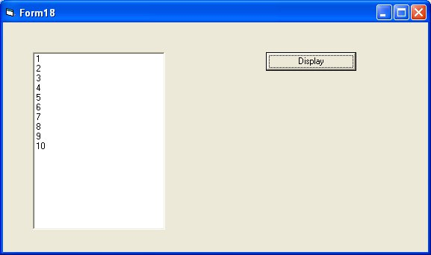

program to input two numbers and display list of all numbers between these two numbers

Private Sub Command1_Click()
Dim a As Integer
Dim b As Integer
Dim i As Integer
a = CInt(Text1.Text)
b = CInt(Text2.Text)
For i = a To b
List1.AddItem (i)
Next
End Sub

Private Sub Command2_Click()
List1.Clear
End Sub

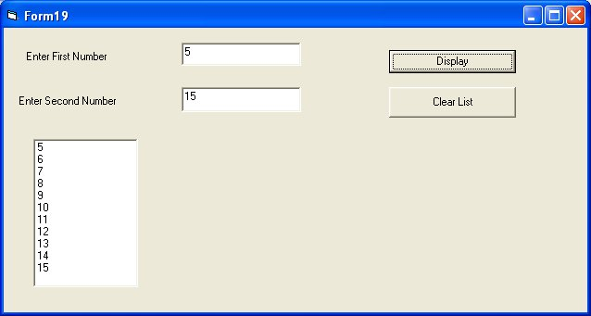
program to display sum between two numbers and display sum of numbers between them
we are assuming number 1 is less than number 2

Private Sub Command1_Click()
Dim a As Integer
Dim b As Integer
Dim i As Integer
Dim sum As Integer
sum = 0
a = CInt(Text1.Text)
b = CInt(Text2.Text)
For i = a To b
sum = sum + i
Next
MsgBox ("Sum of numbers between " & a & " and " & b & " is " & sum)
End Sub

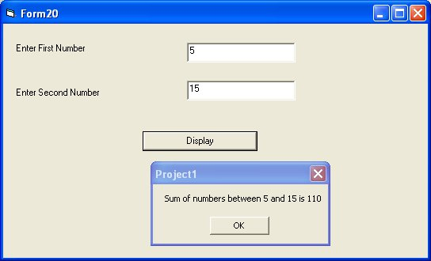
program to find factorial of a number

Private Sub Command1_Click()
Dim i As Integer
Dim a As Integer
Dim fact As Integer
fact = 1
a = CInt(Text1.Text)
For i = 1 To a
fact = fact * i
Next
MsgBox ("Factorial of " & a & " is " & fact)
End Sub

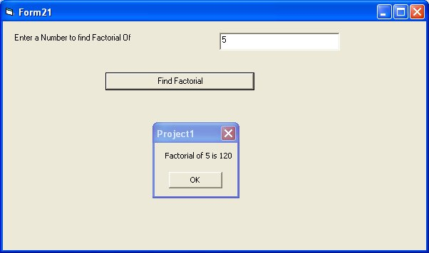
program to find whether number is prime or not

Private Sub Command1_Click()
Dim a As Integer
Dim i As Integer
Dim prime As Boolean
prime = True
a = CInt(Text1.Text)
For i = 2 To a / 2
If a Mod i = 0 Then
prime = False
Exit For
End If
Next
If prime = True Then
MsgBox (a & " is prime")
Else
MsgBox (a & " is not prime")
End If
End Sub

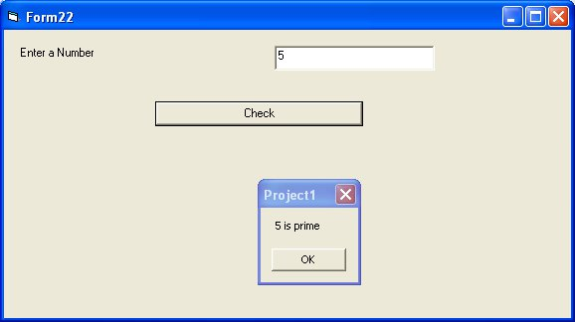
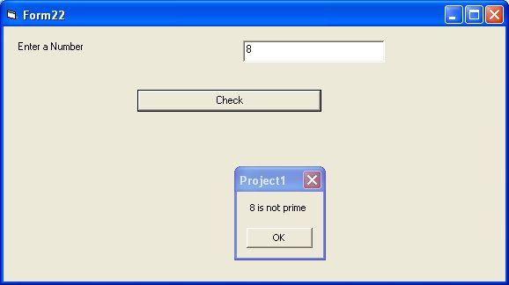
program to print fibonicci series in a listbox

Private Sub Command1_Click()
Dim i As Integer
Dim a As Integer
Dim b As Integer
Dim c As Integer
a = 1
b = 1
List1.AddItem (a)
List1.AddItem (b)
For i = 1 To 10
c = a + b
List1.AddItem (c)
a = b
b = c
Next
End Sub

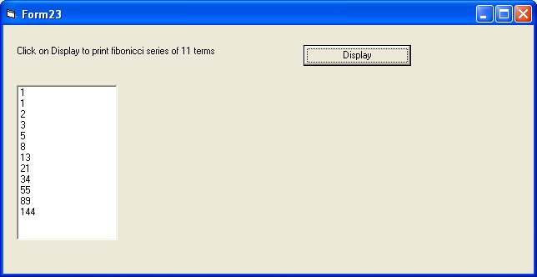
program to display table of a number from 1 to 10 in a listbox

Private Sub Command1_Click()
Dim i As Integer
Dim a As Integer
a = CInt(Text1.Text)
For i = 1 To 10
List1.AddItem (a * i)
Next
End Sub

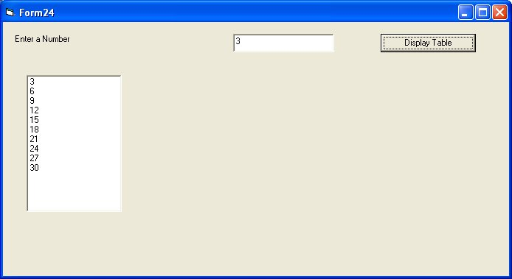
program to demonstrate while loop to display numbers from 1 to 10 using while wend loop

Private Sub Command1_Click()
Dim i As Integer
i = 1
While i <= 10
List1.AddItem (i)
i = i + 1
Wend
End Sub

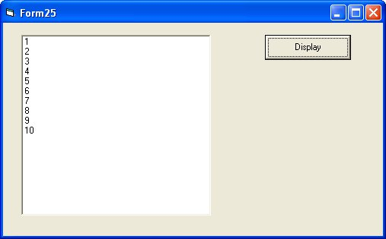

program to demonstrate do while loop statement

Private Sub Command1_Click()
Dim number As Integer
number = 1
Do While number <= 10
List1.AddItem (number)
number = number + 1
Loop
End Sub

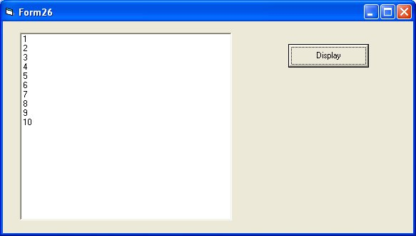
Do...Loop While Statement

The Do...Loop While statement first executes the statements and then test the condition after each execution. The following program block illustrates the structure:

Dim number As Long
number = 0
Do
number = number + 1
Loop While number < 201

Do Until...Loop Statement

Unlike the Do While...Loop and While...Wend repetition structures, the Do Until... Loop structure tests a condition for falsity. Statements in the body of a Do Until...Loop are executed repeatedly as long as the loop-continuation test evaluates to False.

An example for Do Until...Loop statement. The coding is typed inside the click event of the command button

Dim number As Long
number=0
Do Until number > 1000
number = number + 1
Print number
Loop

With Statement

With...End With statement

When properties are set for objects or methods are called, a lot of coding is included that acts on the same object. It is easier to read the code by implementing the With...End With statement. Multiple properties can be set and multiple methods can be called by using the With...End With statement. The code is executed more quickly and efficiently as the object is evaluated only once. The concept can be clearly understood with following example.

With Text1
.Font.Size = 14
.Font.Bold = True
.ForeColor = vbRed
.Height = 230
.Text = "Hello World"
End With

program to add an item to listbox on click of button1
and get selected item from listbox on click of button2

Private Sub Command1_Click()
List1.AddItem (Text1.Text)
End Sub

Private Sub Command2_Click()
Label1.Caption = List1.List(List1.ListIndex)
End Sub

Examples of Controls on Visual Basic 6.0 Toolbox

Frame Control

Private Sub Command1_Click()
MsgBox ("Name you entered is " & Text1.Text)
End Sub

Name on Frame can be changed through Caption Property

Frame1.Caption= “Buttons”

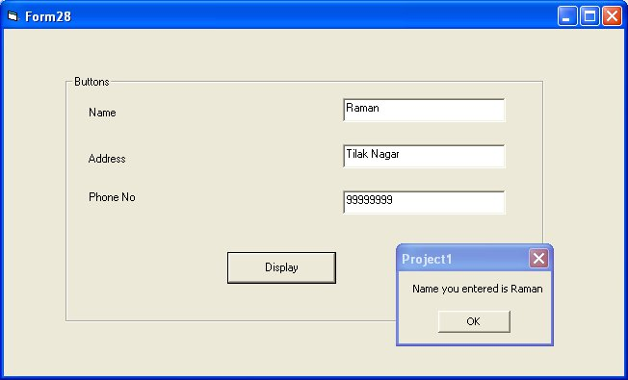
Example of ComboBox

Private Sub Command1_Click()
Dim a As String
a = ""
If Check1.Value = vbChecked Then
a = a & "Cricket,"
End If
If Check2.Value = vbChecked Then
a = a & "Table Tennis,"
End If
If Check3.Value = vbChecked Then
a = a & "BasketBall,"
End If
If a = "" Then
MsgBox ("No Games Selected")
Else
MsgBox ("You play " & a)
End If
End Sub

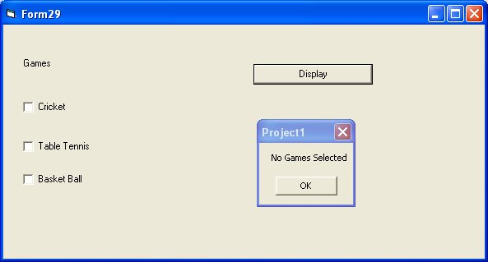
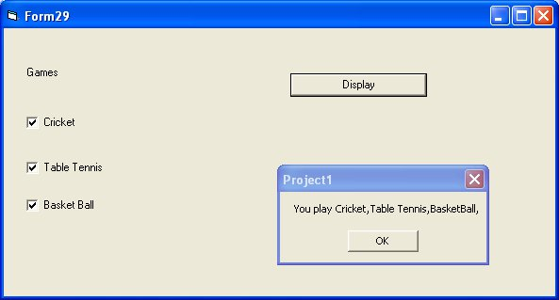
vbChecked is a constant in Visual Basic and a constant starts with vb in Visual Basic

Radio Buttons or Option Buttons in Visual Basic 6.0

If you want to place two radio buttons in form you can use a frame

only a single option button can be selected in a frame

Private Sub Command1_Click()
If Option1.Value = True Then
MsgBox ("Male")
Else
MsgBox ("Female")
End If
End Sub

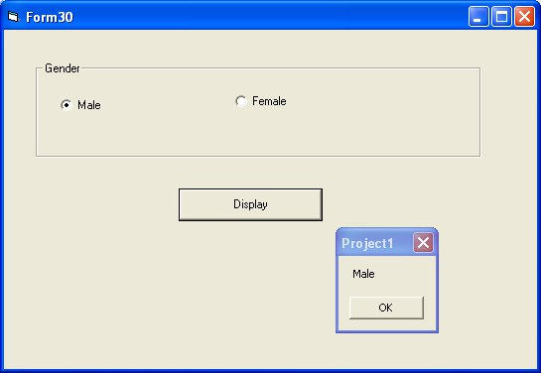

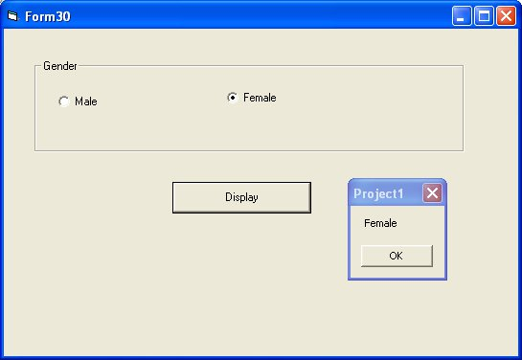
if you want to select a radio button or an option button by default, you can use value property to
be selected as True.

Example of Combo Box Control

Private Sub Command1_Click()
Combo1.AddItem (Text1.Text)
MsgBox (Text1.Text & " added to ComboBox")
End Sub

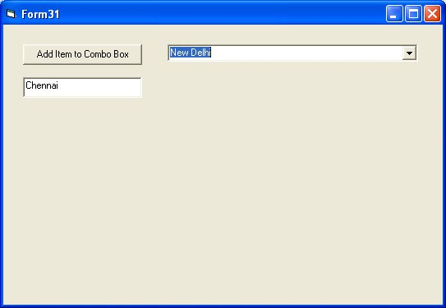
Horizontal Scroll Bar

It is used to display a horizontal scroll bar or slider

Main properties are

- Min
- Max
- Value

Private Sub Command1_Click()
HScroll1.Value = Val(Text1.Text)
End Sub

Private Sub Command2_Click()
MsgBox (HScroll1.Value)
End Sub

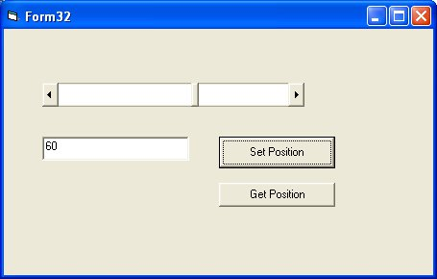
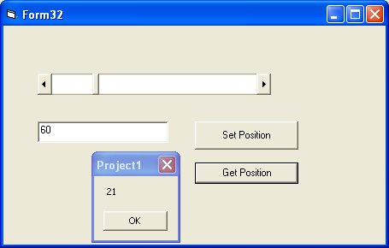

Vertical Scroll Bar

It is used to display a vertical scroll bar or slider

Main properties are

- Min
- Max
- Value

Private Sub Command1_Click()
VScroll1.Value = Val(Text1.Text)
End Sub

Private Sub Command2_Click()
MsgBox (VScroll1.Value)
End Sub

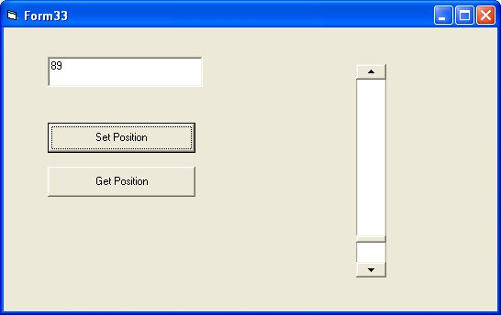

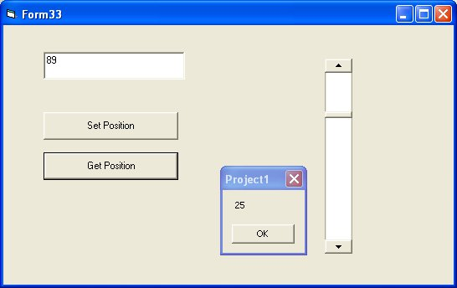
Example of Timer Control

Main property of Timer Control is Interval
Value of Interval is defined in ms so for 5 seconds Value of Interval becomes 5000

Main Event of Timer Control is Timer
Function associated to Timer Event is Timer1_Timer which is invoked after every milliseconds which are defined in Interval Property

Timer Control is a invisible control

Private Sub Command1_Click()
Timer1.Enabled = True
End Sub

Private Sub Command2_Click()
Timer1.Enabled = False
End Sub

Private Sub Timer1_Timer()
MsgBox ("Hello Raman")
End Sub

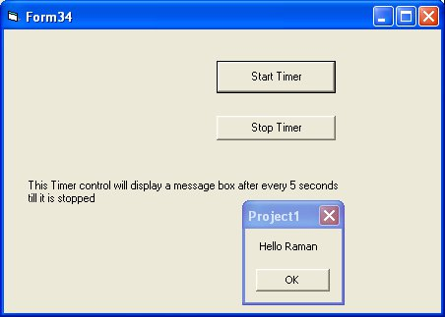

Example of Drive List Box Control

Drive List Box displays all the drives (harddisks,cdroms and usb drives) on the computer.

Place it on Form and it will display all drives in computer as a combo box

Following code displays current selected drive in Drive List Box Control

Private Sub Command1_Click()
MsgBox (Drive1.Drive)
End Sub

Example of Directory List Box Control

Directory List Box displays all folders in a directory

Private Sub Command1_Click()
MsgBox (Dir1.Path)
End Sub

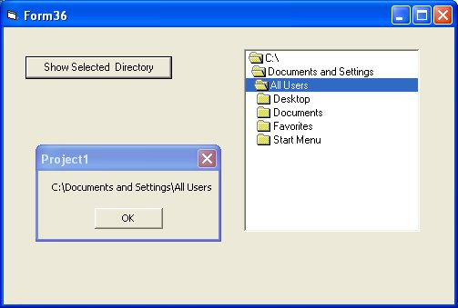
Example of FileListBox Control

File List Box control display lists of all the files in the current working directory

Private Sub Command1_Click()
MsgBox (File1.Path & "\" & File1.FileName)
End Sub

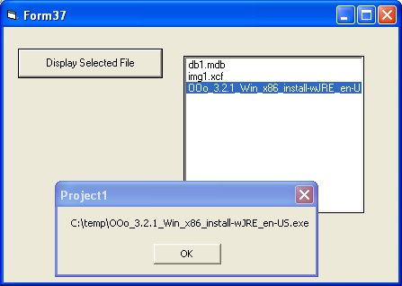

Example of Shape Control

Shape Control is used to display shapes on form like rectangle, circle, oval, Rounded Rectangle, Rounded Square
Shape Property of Shape Control is used to determine which shape you want to display

Shape can have these values

0 – Rectangle
1 – Square
2- Oval
3-Circle
4-Rounded Rectangle
5-Rounded Square

Private Sub Command1_Click()
Shape1.Shape = 3
Shape1.BackColor = vbRed
Shape1.Refresh
End Sub

Above code changes shape from rectangle to circle

Private Sub Command1_Click()
Shape1.Shape = 3
Shape1.BackColor = vbRed
Shape1.Refresh
End Sub

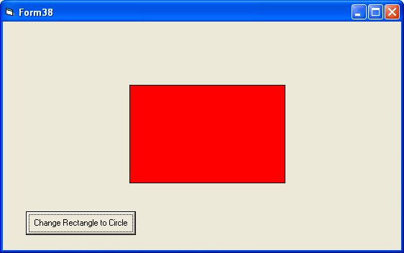

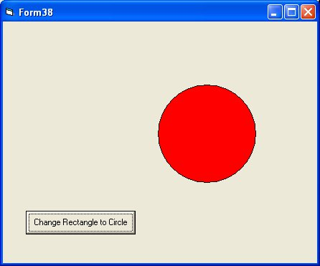
Example of Line Control

Line Control has main properties like

x1,x2,y1,y2 which determine position of line on form

Following code changes the position of line on the form

Private Sub Command1_Click()
Line1.X1 = 100
Line1.Y1 = 100
Line1.X2 = 3000
Line1.Y2 = 3000
End Sub

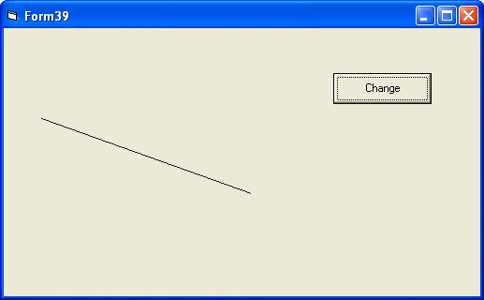
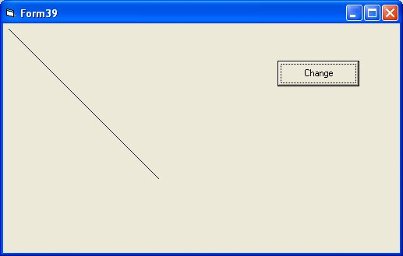

Example of Image Control

Image Control is used to display an image in form
Main property is Picture
Picture can be set to an image through LoadPicture Function

In this example
when button1 is clicked image of an apple is shown in Image Box and when button2 is clicked image of a ball is shown in the imagebox

Private Sub Command1_Click()
Image1.Picture = LoadPicture("c:\temp\aimage.jpg")
End Sub

Private Sub Command2_Click()
Image1.Picture = LoadPicture("c:\temp\bimage.jpg")
End Sub

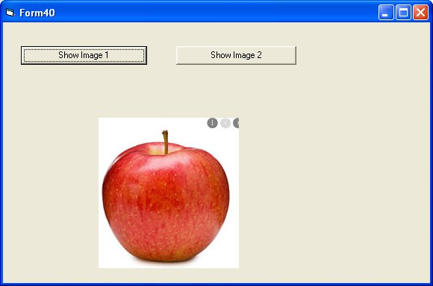

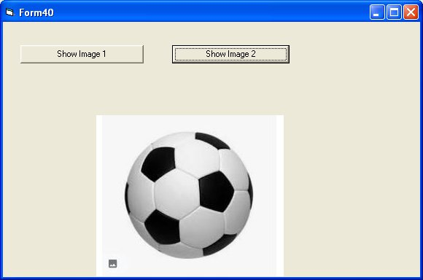
Example of PictureBox Control

PictureBox Control can be used to display a picture in a form

Private Sub Command1_Click()
Picture1.Picture = LoadPicture("c:\temp\aimage.jpg")
End Sub

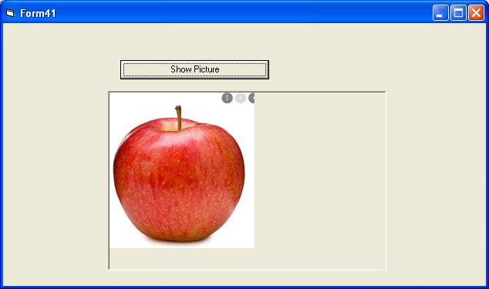
Connecting to Databases using ADODB Control

Get Records from a Access Database and display in a ListView

ListView Control is present in Microsoft Windows Common Controls 6.0

Private Sub Command1_Click()
Dim myCon As New ADODB.Connection
Dim rs As New ADODB.Recordset
Dim lst As ListItem
ListView1.ListItems.Clear
myCon.ConnectionString = "Provider=Microsoft.Jet.OLEDB.4.0;Data Source=c:\temp\db1.mdb"
myCon.Open
Set rs = New ADODB.Recordset
rs.Open "select * from students", myCon, adOpenDynamic, adLockOptimistic
Dim ListX As ListItem

Me.ListView1.ListItems.Clear
While Not rs.EOF = True
Set lst = Me.ListView1.ListItems.Add(, , rs.Fields("rollno"))
lst.SubItems(1) = rs.Fields("name")
lst.SubItems(2) = rs.Fields("marks")

rs.MoveNext
Wend
Me.ListView1.Refresh

End Sub

Private Sub Command1_Click()
Dim myCon As New ADODB.Connection
Dim rs As New ADODB.Recordset
Dim lst As ListItem
ListView1.ListItems.Clear
myCon.ConnectionString = "Provider=Microsoft.Jet.OLEDB.4.0;Data Source=c:\temp\db1.mdb"
myCon.Open
Set rs = New ADODB.Recordset
rs.Open "select * from students", myCon, adOpenDynamic, adLockOptimistic
Dim ListX As ListItem

Me.ListView1.ListItems.Clear
While Not rs.EOF = True
Set lst = Me.ListView1.ListItems.Add(, , rs.Fields("rollno"))
lst.SubItems(1) = rs.Fields("name")
lst.SubItems(2) = rs.Fields("marks")

rs.MoveNext
Wend
Me.ListView1.Refresh

End Sub

Add a Record to Database using ADODB

Private Sub Command1_Click()
Dim con As New ADODB.Connection
Dim cmd As New ADODB.Command
con.ConnectionString = "Provider=Microsoft.Jet.OLEDB.4.0;Data Source=c:\temp\db1.mdb"
con.Open
Dim sql As String
sql = "insert into students values ("
sql = sql & "'" & Text1.Text & "',"
sql = sql & "'" & Text2.Text & "',"
sql = sql & "'" & Text3.Text & "')"
cmd.ActiveConnection = con
cmd.CommandText = sql
cmd.Execute
MsgBox "Record Inserted to Database"
End Sub

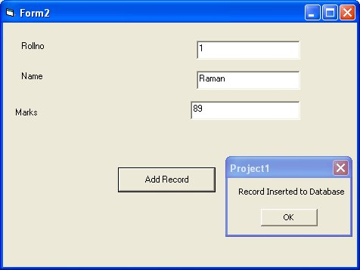

Update Record

Private Sub Command1_Click()
Dim con As New ADODB.Connection
Dim rs As New ADODB.Recordset
Dim cmd As New ADODB.Command
Dim count As Integer
count = 0
con.ConnectionString = "Provider=Microsoft.Jet.OLEDB.4.0;Data Source=c:\temp\db1.mdb"
con.Open
Set rs = New ADODB.Recordset
rs.Open "select * from students where rollno=" & Text1.Text, con, adOpenDynamic, adLockOptimistic
While Not rs.EOF = True
count = count + 1
rs.MoveNext
Wend
If count > 0 Then
Dim sql As String
sql = "update students set name='" & Text2.Text & "',marks=" & Text3.Text & " where rollno=" & Text1.Text
cmd.ActiveConnection = con
cmd.CommandText = sql
cmd.Execute
Else
MsgBox ("No Such Record Exists")
End If
MsgBox ("Record Updated")
End Sub

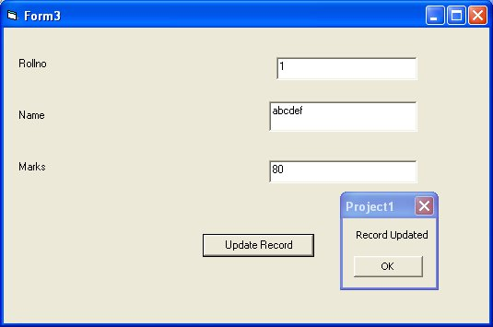

Delete a Record

Private Sub Command1_Click()
Dim con As New ADODB.Connection
Dim rs As New ADODB.Recordset
Dim cmd As New ADODB.Command
Dim count As Integer
count = 0
con.ConnectionString = "Provider=Microsoft.Jet.OLEDB.4.0;Data Source=c:\temp\db1.mdb"
con.Open
Set rs = New ADODB.Recordset
rs.Open "select * from students where rollno=" & Text1.Text, con, adOpenDynamic, adLockOptimistic
While Not rs.EOF = True
count = count + 1
rs.MoveNext
Wend
If count > 0 Then
Dim sql As String
sql = "delete from students where rollno=" & Text1.Text
cmd.ActiveConnection = con
cmd.CommandText = sql
cmd.Execute
MsgBox ("Record Deleted")
Else
MsgBox ("No Such Record Exists")
End If
End Sub

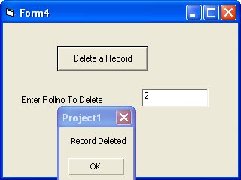
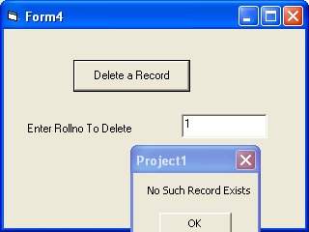
Example of TreeView Control

In the example below we read student records from access database and display records in a treeview
click

TreeView Control is present in Microsoft Windows Common Controls 6.0

Private Sub Command1_Click()
Dim Node1, Node2, Node3 As Node
Set Node1 = TreeView2.Nodes.Add
TreeView2.Nodes(1).Text = "Node 1"
TreeView2.Nodes(1).Key = "Node 1"
Set Node2 = TreeView2.Nodes.Add("Node 1", tvwChild, "Node 2")
TreeView2.Nodes(2).Text = "Node 2"
TreeView2.Nodes(2).Key = "Node 2"
Set Node3 = TreeView2.Nodes.Add("Node 1", tvwChild, "Node 3")
TreeView2.Nodes(3).Text = "Node 3"
TreeView2.Nodes(3).Key = "Node 3"
End Sub

Private Sub Command2_Click()
TreeView1.Nodes.Clear
Dim myCon As New ADODB.Connection
Dim rs As New ADODB.Recordset
myCon.ConnectionString = "Provider=Microsoft.Jet.OLEDB.4.0;Data Source=c:\temp\db1.mdb"
myCon.Open
rs.Open "select * from students", myCon, adOpenDynamic, adLockOptimistic
Dim rollno As Integer
Dim cname, NameKey, name, rollnokey, markskey As String
Dim marks As Integer

Dim NodeRoot, noderollno, nodename, nodemarks As Node
Dim i As Integer
i = 0
Set NodeRoot = TreeView1.Nodes.Add(, , "RootDB", "Students", 0)
While Not rs.EOF = True

rollno = rs.Fields("rollno").Value
name = rs.Fields("name").Value
marks = rs.Fields("marks").Value
rollnokey = "R" & Str(i)
NameKey = "N" & name
markskey = "M" & Str(marks)
Set noderollno = TreeView1.Nodes.Add("RootDB", tvwChild, rollnokey, rollno, 0)
Set nodename = TreeView1.Nodes.Add(rollnokey, tvwChild, NameKey, name, 0)
Set nodemarks = TreeView1.Nodes.Add(rollnokey, tvwChild, markskey, marks, 0)
i = i + 1
rs.MoveNext
Wend
End Sub

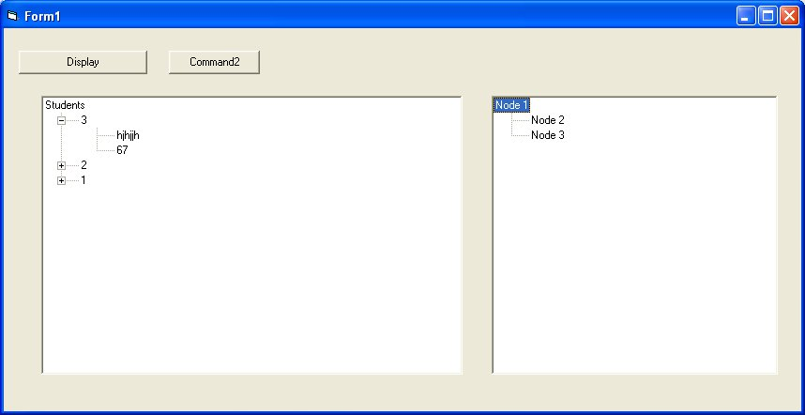
Progress Bar Example in Visual Basic 6

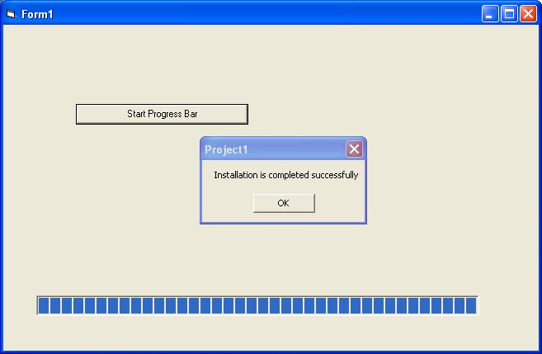
Private Sub Command1_Click()
Timer1.Interval = 50
Timer1.Enabled = True
End Sub

Private Sub Timer1_Timer()
ProgressBar1.Value = ProgressBar1.Value + 50
If ProgressBar1.Value = ProgressBar1.Max Then
Timer1.Enabled = False
MsgBox "Installation is completed successfully"
End If
End Sub

ToolBox Control

Private Sub Toolbar1_ButtonClick(ByVal Button As MSComctlLib.Button)
Select Case Button.Index
Case 1: MsgBox ("Button 1 is pressed")
Case 2: MsgBox ("Button 2 is pressed")
Case 3: MsgBox ("Button 3 is pressed")
Case 4: MsgBox ("Button 4 is pressed")
End Select
End Sub

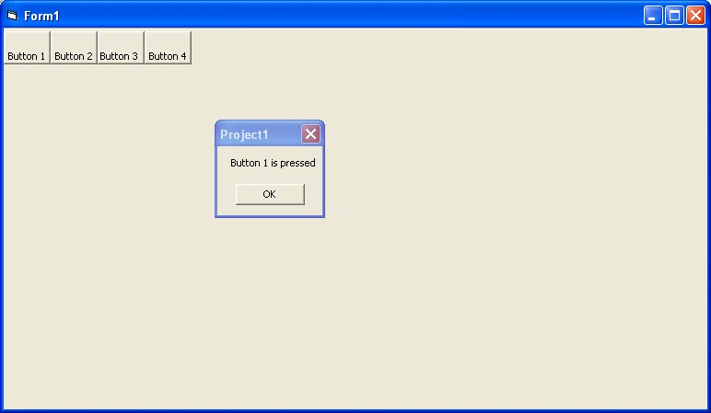

Status Bar Control in Visual Basic 6.0

Status Bar has Panels and value of a Panel can be set through Text Property

Private Sub Command1_Click()
StatusBar1.Panels(3).Text = StatusBar1.Panels(1).Text & " " & StatusBar1.Panels(2).Text
End Sub

Private Sub Command2_Click()
StatusBar1.Panels(1).Text = Text1.Text
StatusBar1.Panels(2).Text = Text2.Text
End Sub

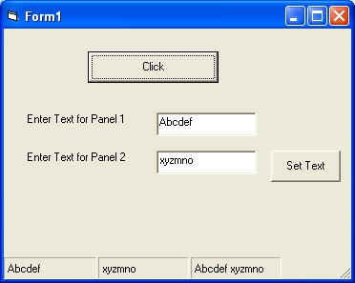

ImageList Control in Visual Basic 6.0
it is present in Microsoft Windows Common Controls 6.0

Private Sub Command1_Click()
Dim a As Integer
a = Text1.Text
Picture1.Picture = ImageList1.ListImages(a).Picture
End Sub

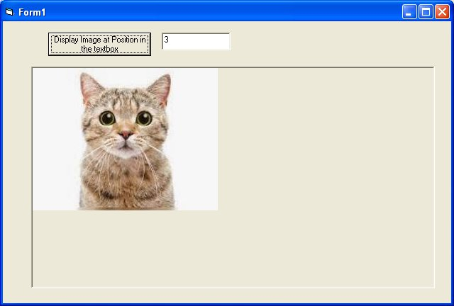
Example of Microsoft Common Dialog Controls

Go to Components and find Microsoft Common Dialog Controls

Private Sub Command1_Click()
CommonDialog1.Filter = "Apps (*.txt)|*.txt|All files (*.*)|*.*"
CommonDialog1.DefaultExt = "txt"
CommonDialog1.DialogTitle = "Select File"
CommonDialog1.ShowOpen

'The FileName property gives you the variable you need to use
Label1.Caption = CommonDialog1.FileName
End Sub

Common Dialog control can be used to select a text file from Harddisk/Floppy Disk/CDRom
The above example will choose a text file from any drive on the computer



