How to make a Java Web Application in Netbeans 8 using MySQL and Apache Tomcat version 7
First of all create a database with name studentsdata in Mysql server
Command is
Create database studentsdata;
Next command is
Use studentsdata;
Next command is
Create table students(rollno int,name varchar(20),marks int);
How to create a web application in netbeans
If Java Web option is not present in New Java Project, you need to add a plugin with the name as
JEE Base
You can go to Tool-> Plugins and go to Available Plugins and then check the box Java EE Base Plugin
Click on Install and Java EE Base plugin will be install after downloading the dependencies.
Now we will create a Java Web Application names as studentsservlet which add records in studentsdata, delete records from studentsdata, update studentsdata, search studentsdata, and read all records from studentsdata.
Go to New Project - > Java Web -> Web Application
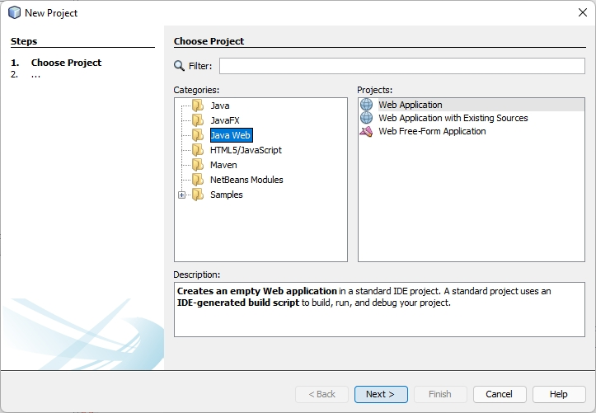
Now Click Next
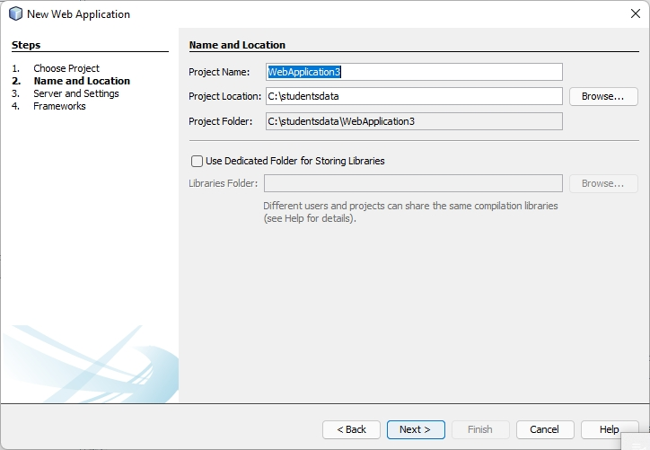
Click Next
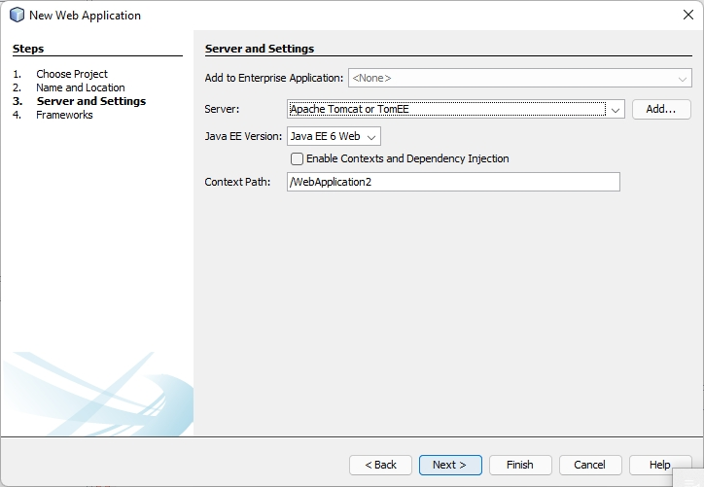

Now Click Next
Following Window will appear
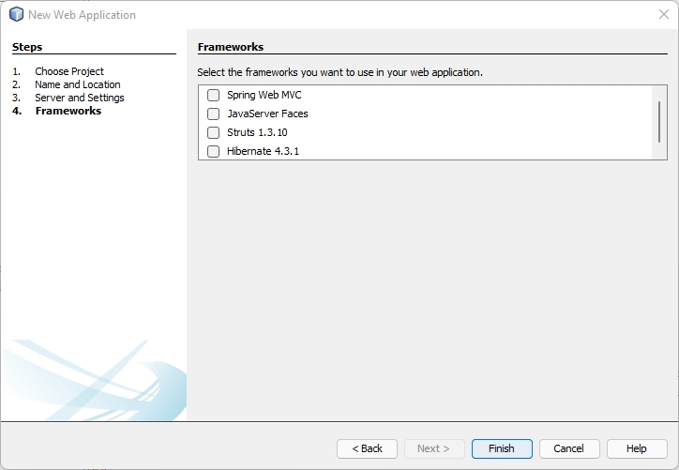
We will not use any Frameworks as these frameworks, Spring, Java Server Faces, Struts, Hibernate
We will only use servlets.
Click Finish
Now WebApplication2 will appear in Projects, there will be a file index.jsp.
Edit index.jsp file as
<%@page contentType="text/html" pageEncoding="UTF-8"%>
<!DOCTYPE html>
<html>
<head>
<meta http-equiv="Content-Type" content="text/html; charset=UTF-8">
<title>Add a Student Record</title>
</head>
<body>
<form action='addrecord' method='post'>
Roll No : <input type='text' value='1' name='rollnotxt'>
<br>
Name : <input type='text' value='Raman' name='nametxt'>
<br>
Marks : <input type='text' value='90' name='markstxt'>
<br>
<input type='submit' value='Add a Student Record'>
</form>
</body>
</html>
Run this file in Browser and following screen will appear

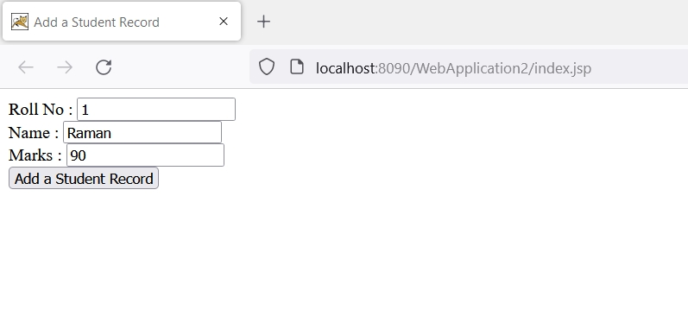

Now go to WebApplication2 -> Libraries -> Add JAR/Folder -> (Add JDBC Driver Jar File for MySQL)
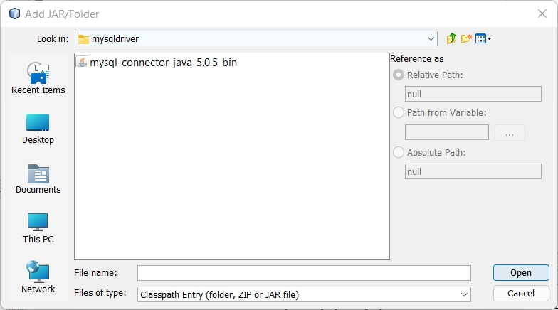
After the jar file has been added to Libraries
Go to -> WebApplication2 -> Source Packages and right click on default package.
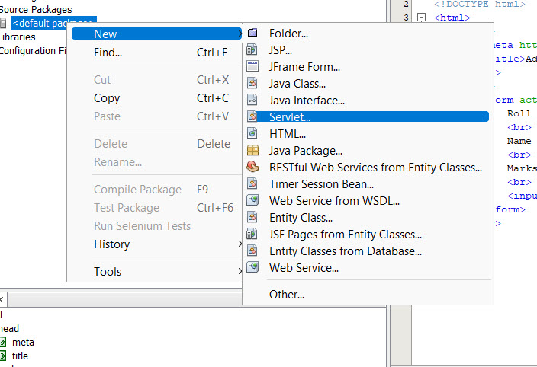

After selecting Servlet following screen will appear
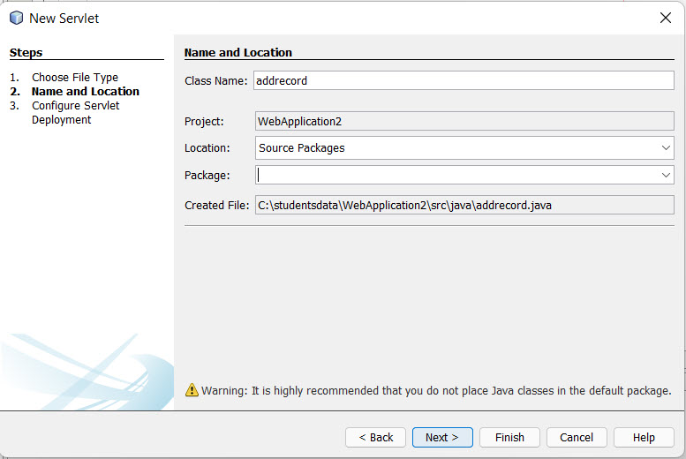
Click on Next
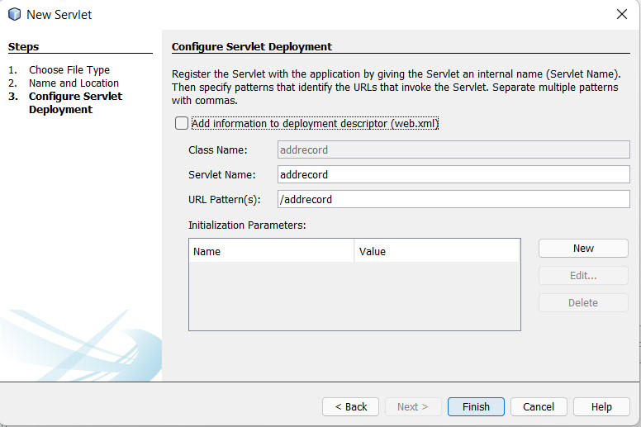

Now Source Code window will appear
Add import statement
import java.sql.*;
in the servlet file
In the processrequest function of the servlet write code
protected void processRequest(HttpServletRequest request, HttpServletResponse response)
throws ServletException, IOException {
response.setContentType("text/html;charset=UTF-8");
try (PrintWriter out = response.getWriter()) {
/* TODO output your page here. You may use following sample code. */
int rollno;
String name="";
int marks;
rollno=Integer.parseInt(request.getParameter("rollnotxt"));
name=request.getParameter("nametxt");
marks=Integer.parseInt(request.getParameter("markstxt"));
String driverName = "com.mysql.jdbc.Driver";
Class.forName(driverName);
String url ="jdbc:mysql://127.0.0.1:3306/students";
Statement stmt;
int rs;
Connection con =DriverManager.getConnection(url,"root", "");
// Create a connection to the database
stmt = con.createStatement();
rs = stmt.executeUpdate("insert into student values(" + rollno + ",'" + name + "'," + marks + ");");
if(rs>0)
{
out.write("Record Added to Database");
}
}
catch(Exception e)
{
System.out.println(e.toString());
}

}
You will have to run some sql queries in mysql console or command line prompt
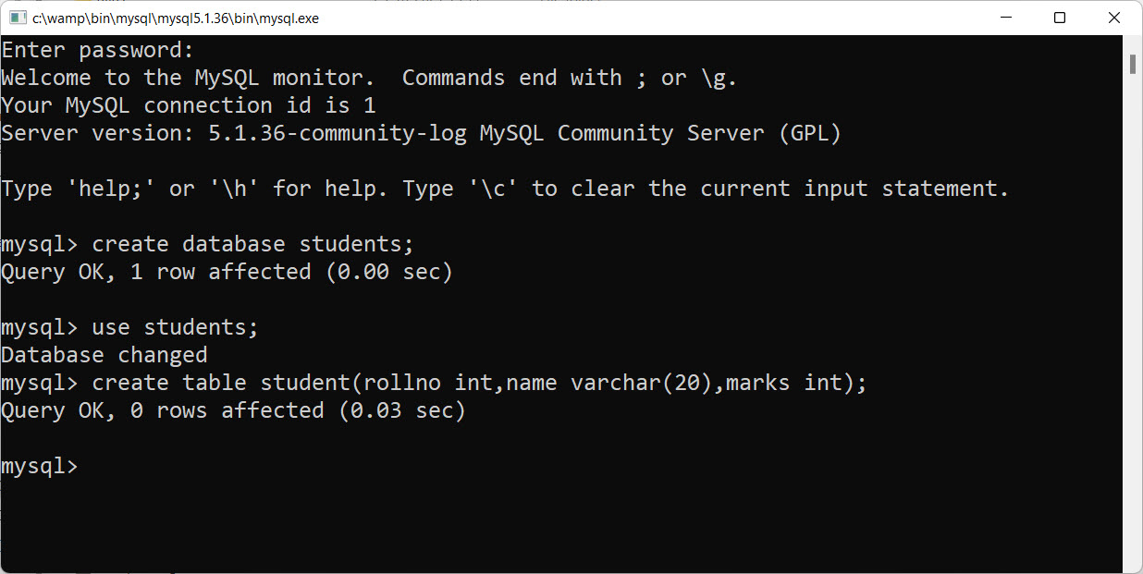
Now run index.jsp in browser and when you will click Add a Student Button following screen will appear if record has been stored in database else there will be an exception.
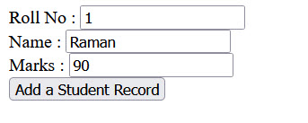
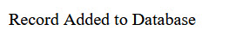

Now we will make a jsp page to show all records in table student of database students
Add the following code to processrequest method (also called as function) to showall.java.
protected void processRequest(HttpServletRequest request, HttpServletResponse response)
throws ServletException, IOException {
response.setContentType("text/html;charset=UTF-8");
try (PrintWriter out = response.getWriter()) {

Statement stmt;
ResultSet rs;
Class.forName("com.mysql.jdbc.Driver");
String url ="jdbc:mysql://127.0.0.1:3306/students";
Connection con =DriverManager.getConnection(url,"root", "");
stmt = con.createStatement();
rs = stmt.executeQuery("SELECT * from student");
int rno;
String name="";
int marks;
int count=0;
while(rs.next()){
rno=rs.getInt("rollno");
name = rs.getString("name");
marks=rs.getInt("marks");
out.write("<br>Roll No : " + rno);
out.write("<br>Name : " + name);
out.write("<br>Marks : " + marks);
out.write("<hr>");
count++;
}
if(count==0)
{
out.write("No Records present in Database");
}
}
catch(Exception e)
{
System.out.println(e.toString());
}

}
Right click on showall.java servlet file and following window will appear
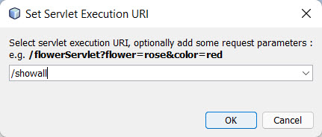
Click Ok and following output will be displayed in browser
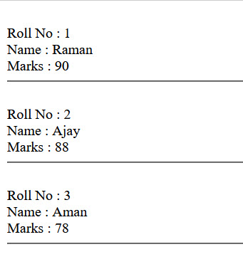
Now we will update arecord with jsp file as update.jsp and servlet as updaterecord.jsp
Update.jsp will take rollno from user and will update student name and marks, if no student rollno is found servlet will display a message “No Record Found”.
Update.jsp
<%@page contentType="text/html" pageEncoding="UTF-8"%>
<!DOCTYPE html>
<html>
<head>
<meta http-equiv="Content-Type" content="text/html; charset=UTF-8">
<title>JSP Page</title>
</head>
<body>
<form action="updaterecord" method="post">
Enter Rollno : <input type="text" name="rollnotxt">
<br>
Enter Name : <input type='text' name='nametxt'>
<br>
Enter Marks : <input type='text' name='markstxt'>
<br>
<input type='submit' value='Update Record'>
</form>
</body>
</html>
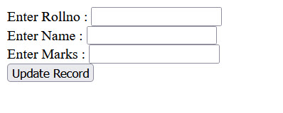

When data will be entered in rollno, name and marks textboxes,
First rollno will be checked in the database if rollno is present in the database for that rollno, name and marks will be updated and message will be shown as Record updated. If rollno is not in database message will be printed as “Record Not Found”.
Servlet updaterecord
public static boolean checkrollno(int rollno)
{
boolean found=false;
int count=0;
try {
Statement stmt;
ResultSet rs;

Class.forName("com.mysql.jdbc.Driver");
String url ="jdbc:mysql://127.0.0.1:3306/students";
Connection con =DriverManager.getConnection(url,"root", "");
stmt = con.createStatement();
rs = stmt.executeQuery("SELECT * from student where rollno=" + rollno);
while(rs.next()){
count++;
}
if(count>0)
{
found=true;
}
}
catch(Exception e)
{
found=false;
}
return found;
}
public static boolean updaterec(int rno,String name,int marks)
{
boolean result=false;
try {

String driverName = "com.mysql.jdbc.Driver";
Class.forName(driverName);
String url ="jdbc:mysql://127.0.0.1:3306/students";
Statement stmt;
int rs;
Connection con =DriverManager.getConnection(url,"root", "");
// Create a connection to the database
stmt = con.createStatement();
rs = stmt.executeUpdate("update student set name='" + name + "',marks="+ marks + " where rollno=" + rno);
if(rs>0)
{
result=true;
}
}
catch(Exception e)
{
result=false;
}
return result;
}
protected void processRequest(HttpServletRequest request, HttpServletResponse response)
throws ServletException, IOException {
response.setContentType("text/html;charset=UTF-8");
try (PrintWriter out = response.getWriter()) {
/* TODO output your page here. You may use following sample code. */
int rollno;
String name="";
int marks;
boolean found=false;
boolean success=true;
rollno=Integer.parseInt(request.getParameter("rollnotxt"));
name=request.getParameter("nametxt");
marks=Integer.parseInt(request.getParameter("markstxt"));
found=checkrollno(rollno);
if(found==true)
{
success=updaterec(rollno,name,marks);
if(success==true)
{
out.write("Record Updated");
}
}
else
{
out.write("Record Not Found");
}
}
catch(Exception e)
{
e.printStackTrace();
}

}
If servlet ran successfully following window will appear

If There will be some exception in running on servlet or no record found for that rollno
Message will be printed as


